[![Review Assignment Due Date](https://classroom.github.com/assets/deadline-readme-button-22041afd0340ce965d47ae6ef1cefeee28c7c493a6346c4f15d667ab976d596c.svg)](https://classroom.github.com/a/vbnbTt5m)

[![Open in Visual Studio Code](https://classroom.github.com/assets/open-in-vscode-2e0aaae1b6195c2367325f4f02e2d04e9abb55f0b24a779b69b11b9e10269abc.svg)](https://classroom.github.com/online_ide?assignment_repo_id=15292006&assignment_repo_type=AssignmentRepo)

# Dev_Setup

Setup Development Environment

#Assignment: Setting Up Your Developer Environment

#Objective:

This assignment aims to familiarize you with the tools and configurations necessary to set up an efficient developer environment for software engineering projects. Completing this assignment will give you the skills required to set up a robust and productive workspace conducive to coding, debugging, version control, and collaboration.

#Tasks:

**1. **Select Your Operating System (OS):\*\***

Choose an operating system that best suits your preferences and project requirements.

Download Ubuntu 22.04: Go to the official Ubuntu download page and download the ISO file.https://releases.ubuntu.com/22.04/

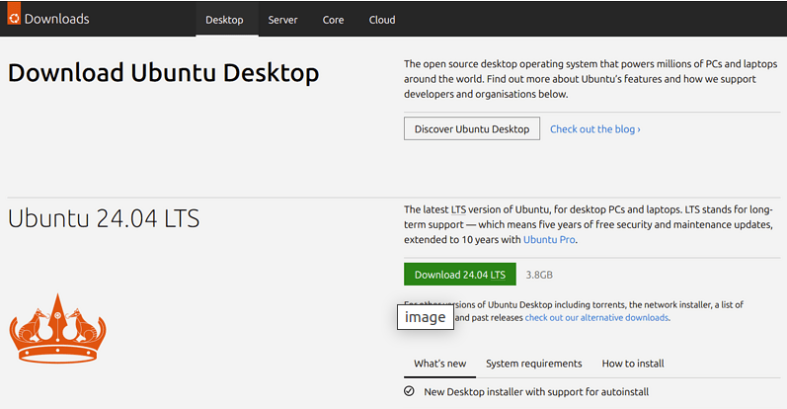

![alt text](image-31.png

**Create a Bootable USB Drive: Use tools like Rufus (Windows) or dd (Linux) to create a bootable USB drive.**

![alt text](image-2.png)

**Boot from the USB drive and follow the installation instructions.**

we’ll use balenaEtcher, as it runs on Linux,

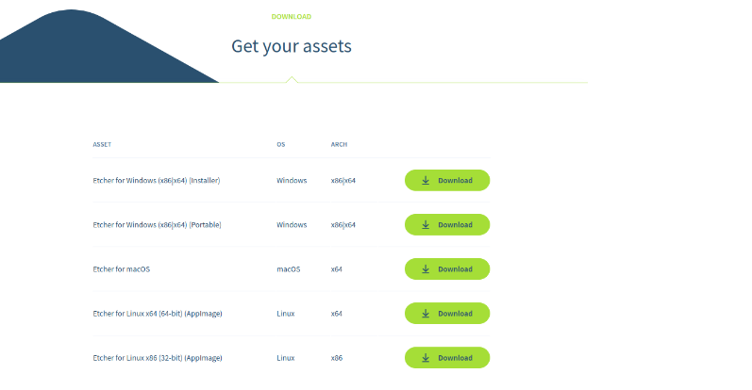

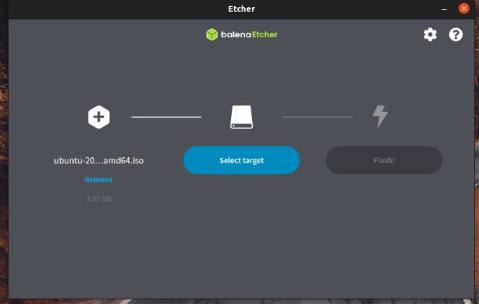

Once the installer has initialised you will be invited to choose your language

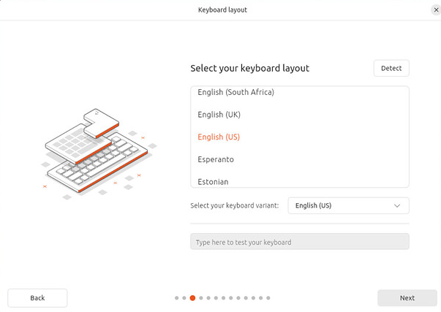

And then presented with the option to select any accessibility settings your require.

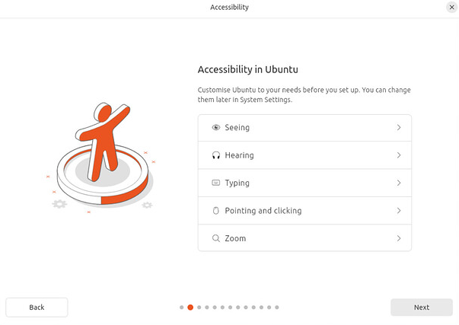

A connect to your network. This will allow Ubuntu to download updates and third party drivers (such as NVIDIA graphics drivers) during installation.

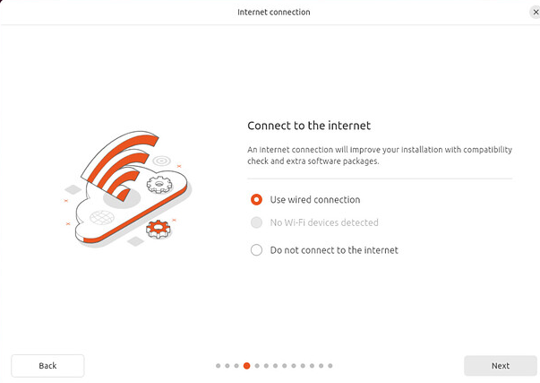

You are then offered the choice to try or install Ubuntu.

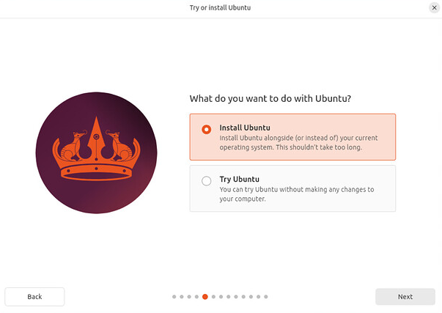

**\*\*installation\*\***

This screen allows you to configure your installation. If you would like Ubuntu to be the only operating system on your hard drive, select Erase disk and install Ubuntu.

If your device currently has another operating system installed, you will receive additional options to install Ubuntu alongside that OS rather than replacing it.

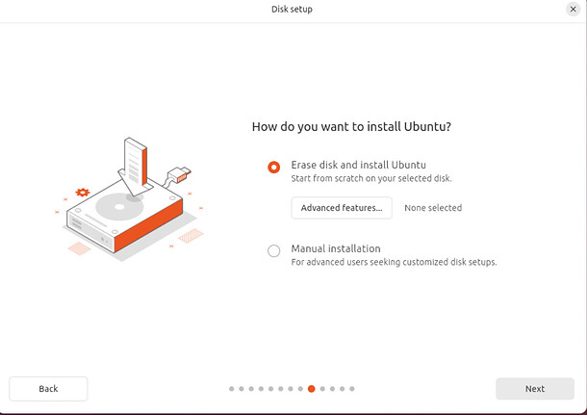

**Create Your Login Details**

On this screen, you will be prompted to enter your name and the name of your computer as it will appear on the network. Finally, you will create a username and a strong password.

You can choose to log in automatically or require a password. If you are using your device whilst travelling, it’s recommended to keep “Require my password to log in” enabled.

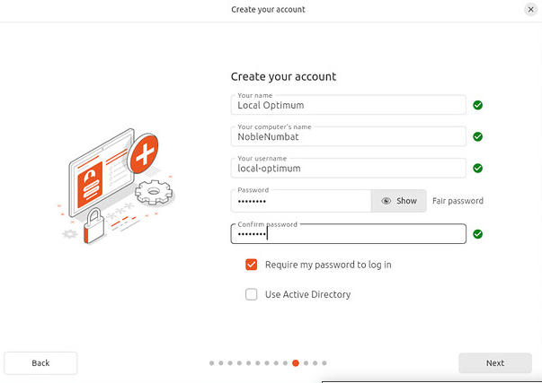

**Choose your Location**

Select your location and timezone from the map screen and click Continue. This information will be detected automatically if you are connected to the internet.

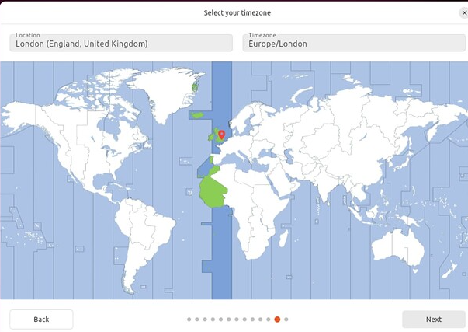

Clicking Next will take you to a summary of your installation configuration to give you a chance to confirm your setup before clicking Install.

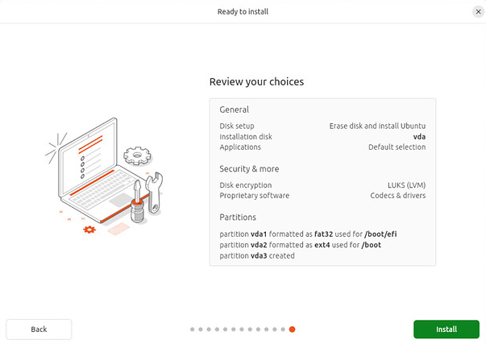

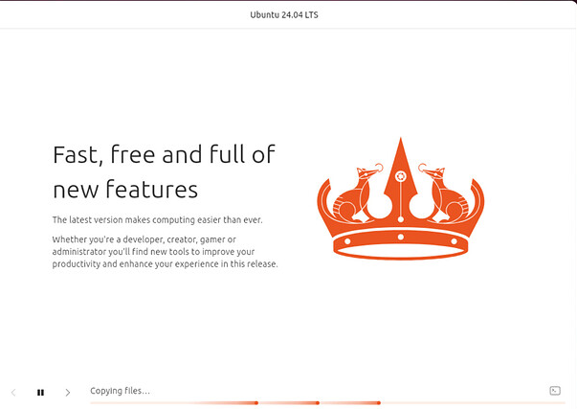

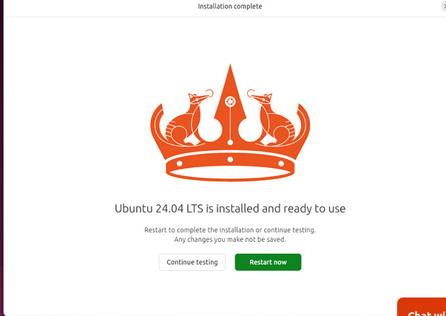

where you can enter your username and password.

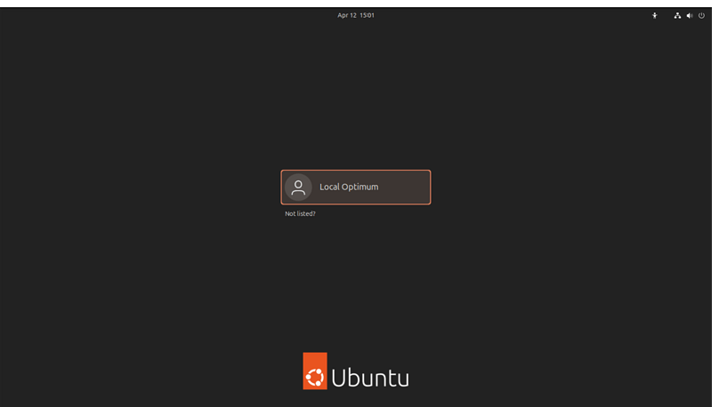

**\*\*2. Install a Text Editor or Integrated Development Environment (IDE):\*\***

Install Visual Studio Code.I installed it using the GUI

visit this

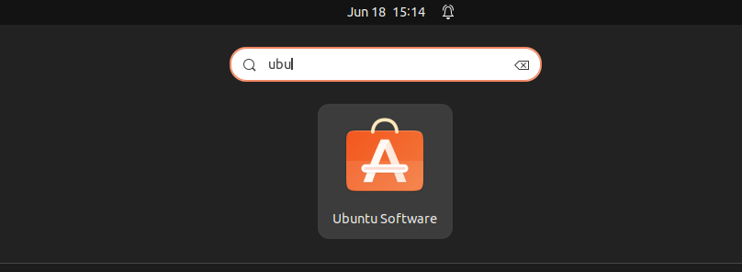

Search for vscode

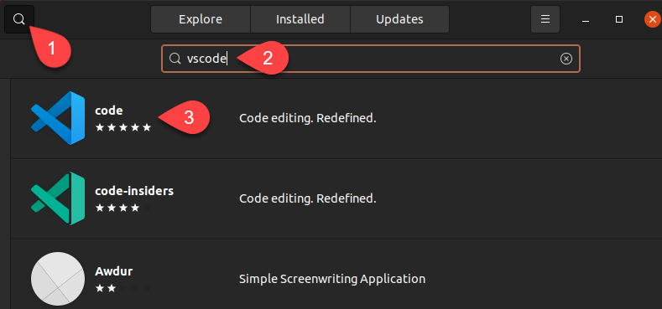

Click on install it

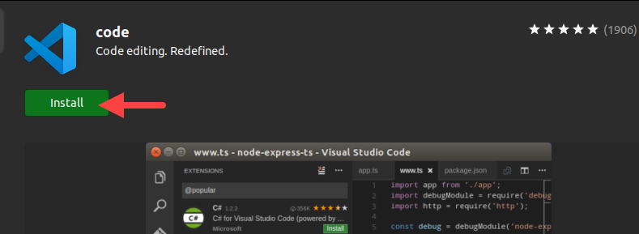

You can now see it in your applications once download is complete

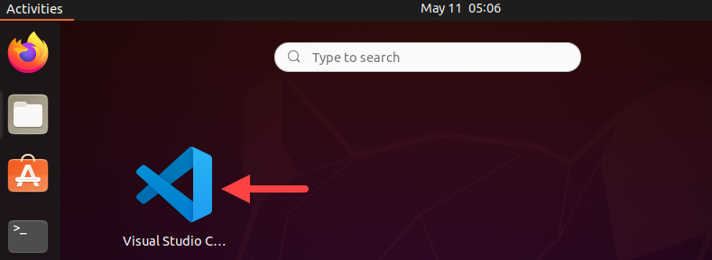

You can open it and now install important extensions

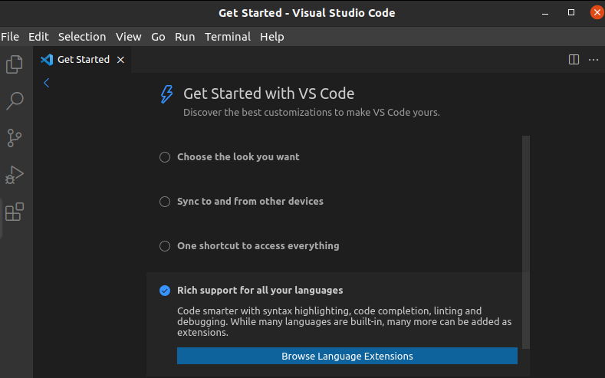

**\*\*3. Set Up Version Control System:\*\***

Install Git and configure it on your local machine. Create a GitHub account for hosting your repositories. Initialize a Git repository for your project and make your first commit.

installation

sudo apt update

sudo apt install git



Create a GitHub account for hosting your repositories. Initialize a Git repository for your project and make your first commit.

git config --global user.name "urbanus-dev"

git config --global user.email "urbanuswambua2019@gmail.com"

mkdir myProject

cd myProject

git init

touch README.md

git add README.md

git commit -m "Initial commit"

https://github.com/urbanus-dev/myProject

**\*\*4. Install Necessary Programming Languages and Runtimes:\*\***

Instal Python

sudo apt update

sudo apt install python3 python3-pip

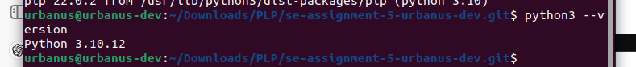

**5. Install Package Managers:**

If applicable, install package managers like pip (Python).

pip: Already installed with Python in the previous step

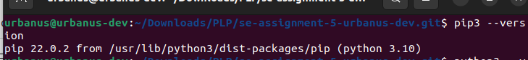

**6. Configure a Database (MySQL):**

sudo apt update

sudo apt install mysql-server

sudo systemctl start mysql

sudo mysql -u root -p

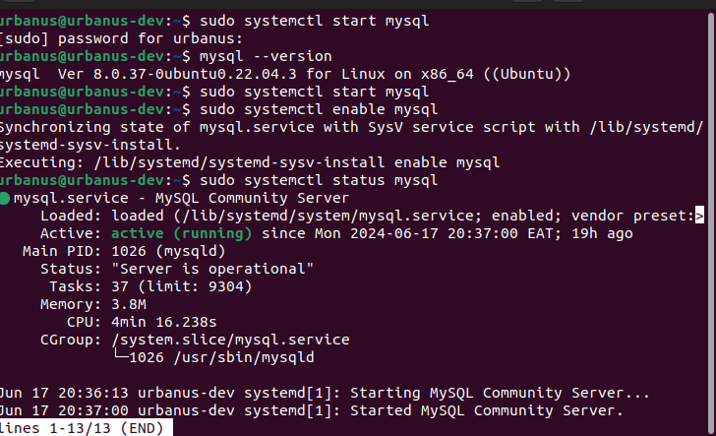

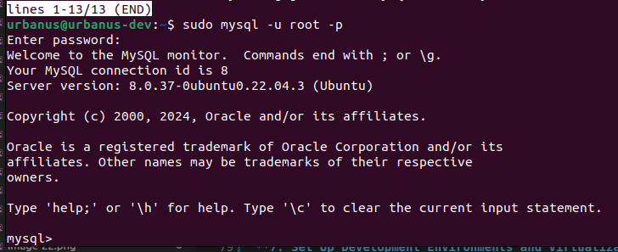

**\*\*7. Set Up Development Environments and Virtualization (Optional):\*\***

sudo apt update

sudo apt install apt-transport-https ca-certificates curl software-properties-common

curl -fsSL https://download.docker.com/linux/ubuntu/gpg | sudo gpg --dearmor -o /usr/share/keyrings/docker-archive-keyring.gpg

echo "deb [arch=amd64 signed-by=/usr/share/keyrings/docker-archive-keyring.gpg] https://download.docker.com/linux/ubuntu $(lsb_release -cs) stable" | sudo tee /etc/apt/sources.list.d/docker.list > /dev/null

sudo apt update

sudo apt install docker-ce

sudo systemctl status docker

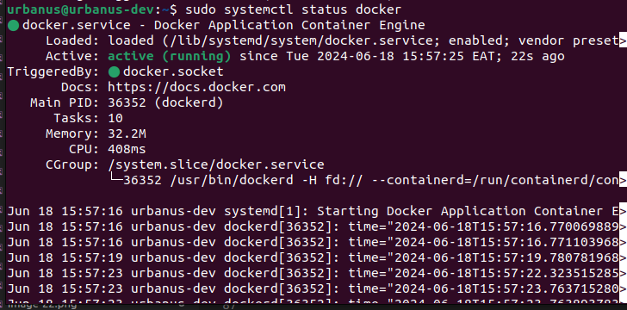

docker --version

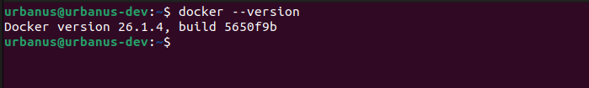

**\*\*8. Explore Extensions and Plugins:\*\***

Explore available extensions, plugins, and add-ons for your chosen text editor or IDE to enhance functionality, such as syntax highlighting, linting, code formatting, and version control integration.

Open VS Code

Go to the Extensions view by clicking on the Extensions icon in the Activity Bar on the side of the window or by pressing Ctrl+Shift+X.

Search and install the following extensions:

Python

GitLens

Docker